**QR Label printing logic**

**Program name: ZQR_PRINT** (QR Code Label printing program)

**Create new Z-Table**- ZQR_MAT_DTLS

**(Do not use any other name for table, smartform or program also, it should be start with ZQR** Only)**

|  |  |  |  |  |  |  |
| --- | --- | --- | --- | --- | --- | --- |
| **Plant** | **Material** | **Size** | **Type** | **Colour** | **Length(In Mtr)** | **Customer code** |
| UCAB | 231212109 | 16/.21 mm (0.50 Sqmm) | FLRY-B (DIN 72551) | GRN/BLU | 1800 | M3232306 |
|  |  |  |  |  |  |  |
|  |  |  |  |  |  |  |
|  |  |  |  |  |  |  |

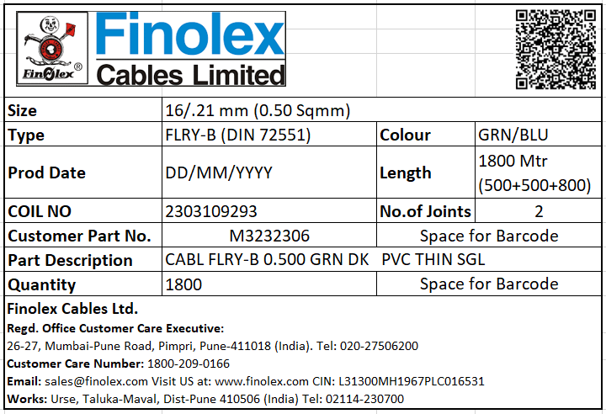

Selection Screen:

|  |  |  |
| --- | --- | --- |
| Coil No | Multiple values input | Mandatory |
| No. of Joints | Single Input |  |
| Cut Length | Single Input | If No. of joints field having value then this field is mandatory (Otherwise it will be display as pop-up screen) |
|  |  |  |

1. **QR Code having Coil No from selection screen**

**Logic to fetch values on smartform-**

1. Pass selection screen coil no (Batch) in the table – MCHB to check the batch having stock & creation date

|  |  |  |  |  |  |  |
| --- | --- | --- | --- | --- | --- | --- |
| **Table** | **Input** | **Input** | **Input** | **Condition** | **Output** | **Output** |
| MCHB | WERKS | LGORT | CHARG | CLABS | ERSDA | MATNR |
|  | Plant | St. Location | Selection screen values from Coil No field | Unrestricted Stock | Creation Date | Material |
|  | UCAB | PROD |  | Not Equal to ZERO |  |  |
|  |  |  |  |  |  |  |

Pass the material & plant into the table - **ZQR_MAT_DTLS**

|  |  |  |  |  |  |  |
| --- | --- | --- | --- | --- | --- | --- |
| **Input** | **Input** | **Output** | **Output** | **Output** | **Output** | **Output** |
| Plant | Material | **Size** | **Type** | **Colour** | **Length(In Mtr)** | **Customer code** |
|  |  |  |  |  |  |  |
|  |  |  |  |  |  |  |
|  |  |  |  |  |  |  |

1. If record having customer code in this table, then it is treated as “Customer Specific” –

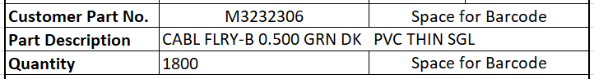

If label is customer specific, then only we need to print the data in below field

* Customer Part Code
* Part Description
* Qty.
* Barcode - Customer part code & Qty

**Otherwise all field is kept blank.**

For Customer specific material values- Pass the material & customer code in the table **ZBARCODEMASTER** to fetch the description

|  |  |  |  |
| --- | --- | --- | --- |
| **Input** | **Input** | **Output** |  |
| SAPCODE | CUSTCODE | CUSTDES |  |
| Material | Customer Code | Part description |  |
|  |  |  |  |

1. Quantity same as **ZQR_MAT_DTLS – Length**
2. **Below part is hard coded-**

